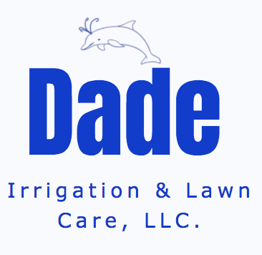
Dade Irrigation, LLC.
2307 Circle Drive
O’Fallon, MO 63368
(636) 561-3593
dadeirrigation@hotmail.com
www.dadeirrigationllc.com

Dear Valued Customer,

Please allow me to thank you for being such a loyal and consistent customer to Dade
Irrigation over the years. Your satisfaction is especially important to us, and we hope we have been successful in providing you with excellent customer service and products.

Service Plans:
Extended Warranty Plan* | Includes yearly maintenance, discounted labor, and discounted parts | $400^{.00}
Yearly Maintenance Plan | Activation, Backflow test, and Winterization | $300^{.00}
Spring Maintenance | Activation and Backflow test only | $175^{.00}
Fall Maintenance | Winterization only | $125^{.00}
Service Call/Labor  Backflow Test Only | Charged hourly  No activation only backflow test for water company | $100^{.00}  $95.⁰⁰
*Extended Warranty Plan offers the following discounts:
- Backflow gasket set and test valves at no additional costs
- Spray or rotor heads at a discounted rate
- Labor rates of $50.00 per hour except on backflow device replacement
Note: This plan does not cover damage caused by excavating equipment or trucks; earthquakes, fire, freezing, vandalism, acts of war, terrorism, or theft.

Additional Services (Call for pricing):
Landscape Lighting
Drip System install

Dade Irrigation, LLC.
2307 Circle Drive
O’Fallon, MO 63368
(636) 561-3593
dadeirrigation@hotmail.com
www.dadeirrigationllc.com

2025 Extended Warranty

Name: _________________________________________________________________
Address: _______________________________________________________________
Home Phone: ____________________ Cell Phone: __________________________
Email: _________________________________________________________________
Water Company: _______________________________________________________

Please select one plan:
- Extended Warranty Plan $400.00
- Yearly Maintenance Plan $300.00

Total Amount Enclosed: ____________

Note: You will receive two automated phone calls per year that serve as maintenance reminders. This first call of the year can be expected in March for an Activation and Backflow test reminder and the second call can be expected in September for a Winterization reminder. Call to schedule your appointment. Thank you for thinking Dade!

Customer Signature: ___________________________________ Date: ____________

